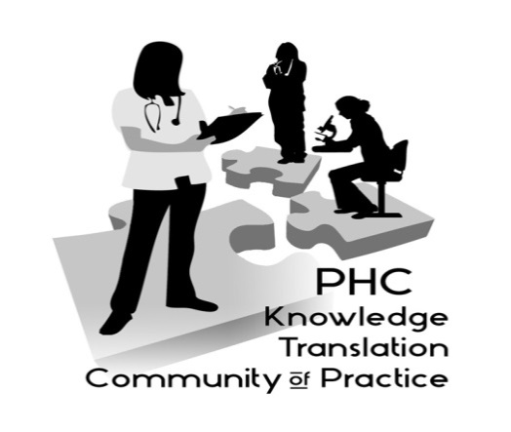

PHC Knowledge Translation (KT) Community of Practice

September 12, 2017, 12:00 PM - 1:00 PM
Dining Rooms 1/2 (by Cafeteria), 4th Floor – Providence Bldg., St. Paul’s Hospital

Alina McKay, PhD Candidate, UBC School of Population and Public Health, shared some of the lessons learned from her work with the Making Research Accessible Initiative (http://learningexchange.ubc.ca/campus/faculty/research/making-research-accessible-initiative/) on plain language summaries for sharing research findings with a variety of audiences. Contact Aggie for handouts from the session.

If you’d like to share a project to elicit ideas from the group or if you have any questions, please contact us:

Aggie Black, Director, Health Services & Clinical Research and Knowledge Translation, (ablack@providencehealth.bc.ca)

Jiak Chin Koh, Resource Dietitian for Clinical Nutrition & Clinical Instructor UBC (jckoh@providencehealth.bc.ca).

For more Information on the KT CoP: http://www.providenceresearch.ca/providence-health-care-knowledge-translation-community-practice

Join the next PHC KT CoP on December 7 at noon when Jason Toal will share his expertise in using visuals to improve presentations.

This session is held in partnership with the BC SUPPORT Unit.

