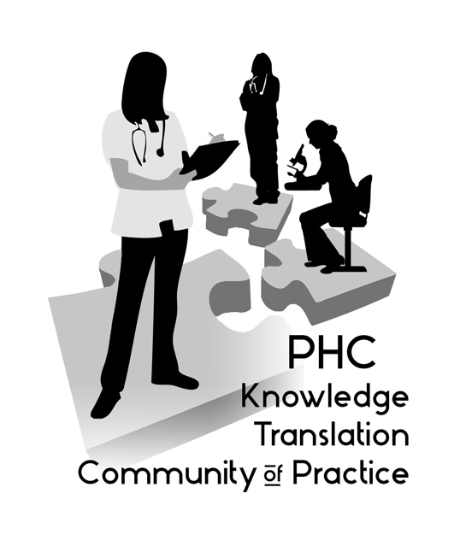

Want to learn with your colleagues about creative and effective ways to improve patient health through use of research evidence? Join the quarterly meetings of the PHC Knowledge Translation (KT) Community of Practice!

Round-table meeting: June 16, 2016
12:00 PM - 1:00 PM – St Paul’s Hospital, Conference Room 6, Lower Level

Our agenda included:

KT Concepts – Alison’s notes on this topic are attached below: “QI vs KT: Same or Different?”

"Brag & Steal" – Preview the KT resources on the KT Clearinghouse website: http://ktclearinghouse.ca/ktcanada The KT Clearinghouse website is funded by CIHR to “serve as the repository of Knowledge Translation resources for individuals who want to learn about the science and practice of KT, and access tools that facilitate their own KT research and practices.” The Alberta SPOR KT platform resource contains even more resources: http://bit.ly/1UE0rJt

"Share & Solve" – Janie Venis, Nursing Instructor at BCIT and ICU Nurse, will share her recent research project on blood sampling practices in the ICU, and the KT efforts she has successfully used to implement change.

If you’d like to share a project to elicit ideas from the group or if you have any questions, please contact us:
Aggie Black, Research Leader, Professional Practice (ablack@providencehealth.bc.ca)

Alison Hoens, Research, Education & Practice Coordinator, Physiotherapy, PHC and Physical Therapy Knowledge Broker, UBC/PHCRI/VCHRI/PABC (ahoens@providencehealth.bc.ca)

More Information: http://www.providenceresearch.ca/ktcommunityofpractice.html

QI and KT: Same or Different?
*The information below includes content that has been modified from that provided in the Practicing KT Course 2015-6 SMU
Quality Improvement:
- Combined and unceasing efforts of everyone - healthcare professionals, patients and their families, researchers, payers, planners and educators - to make the changes that will lead to better patient outcomes (health), better system performance (care) and better professional development (learning) - Bataladen and Davidoff (2007)
- a method of evaluating and improving processes of patient care that focuses not on individuals, but on systems of patient care
- aim is to develop a health care system that is safe, effective, patient-centered, timely, efficient and equitable
- efforts should improve the structure (the way the health care system is designed and the conditions under which care is provided) and processes (all the activities that constitute health care, such as prevention, diagnosis, treatment and education) involved in health care and then monitor related outcomes. http://ktclearinghouse.ca/knowledgebase/knowledgetoaction/action/interventions/strategies/qualityimprovement
KT: may include the entire spectrum that supports the creation and utilization of knowledge: creation, synthesis, dissemination, implementation, evaluation and sustainability
QI | KT
Major emphasis is on quality of implementation | May include entire spectrum of knowledge creation and implementation
Doing things right | Doing the right things
Focuses on the process | Focuses on the evidence
Generally focuses on ‘fidelity’ | Recognizes the need for context specific application Incorporating the concepts of tailoring to barriers and adapting the non-essential elements of the intervention to the setting
Tends on focus on the local level | May focus on local level or on larger context; often includes behavior change

Implementation Science and Improvement science are connected by the common goal of improving outcomes
Challenges of QI alone: Source: Wandersman (2015). “How do improvement science and implementation science contribute to quality and effectiveness in health care?”
- Focus on local level
- Not generalizable
- Not always grounded in theory
- Doesn’t focus on individual behaviour change, great focus on system changes
- Don’t always consider barriers
- Lack of tools/resources
- Not implementing all steps
- Not considering implementation quality

“ According to current implementation science thinking, and as shown in the COM-B model, the behavioural diagnosis and steps to address barriers to critical behaviours that affect the implementation process are central to Implementation Science, whereas in QI and Monitoring & Evaluation (M&E) they often are not. Additionally, the goals of QI research are often less focused on creating generalisable knowledge than on addressing the QI problem at hand. Implementation science focuses more on understanding the aetiology of gaps between expected results and observed outcomes, in ways that can be relevant beyond a given situation, whereas QI and M&E research may stop once identification and barriers related to performance of specific projects are determined. Despite these differences, many QI and M&E-related research studies are aligned with implementation science principles and these disciplinary distinctions are not always relevant. (Handley et al, 2016 Emerg Med)

How does QI fit into KT? Source: The National Implementation Research Network’s Active Implementation Hub (NIRN). Module 3: Implementation Teams http://implementation.fpg.unc.edu/module-3/

