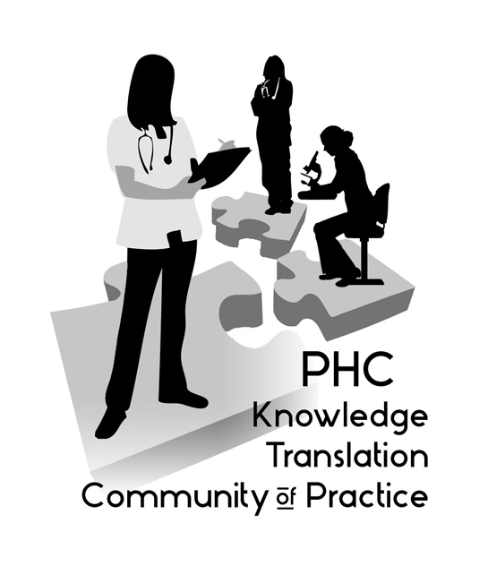
Notes from the December 10, 2015, meeting of the PHC Knowledge Translation (KT) Community of Practice. 12:00 PM - 1:00 PM – St Paul’s Hospital, Conference Room 7, Lower Level

KT Concepts – Alison Hoens discussed a behavior change theory, the COM-B. The Behaviour Change Wheel (BCW) was developed from 19 frameworks of behaviour change identified in a systematic literature review. The hub identifies the sources of the behaviour that could prove fruitful targets for intervention. It uses the COM-B ('capability', 'opportunity', 'motivation' and 'behaviour') model. This model recognizes that behaviour is part of an interacting system involving all these components. Surrounding the hub is a layer of nine intervention functions to choose from based on the particular COM-B analysis one has undertaken. The outer layer, the rim of the wheel, identifies seven policy categories that can support the delivery of these intervention functions. Here is the website: http://www.behaviourchangewheel.com/about-wheel
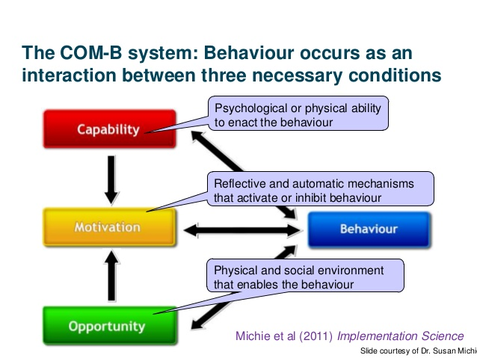

“Brag and Steal” (Showcasing Resources & Tools) – Rx for Change is a database for implementation science tips, including evidence for change and interventions. More at their website: https://www.cadth.ca/resources/rx-for-change/database/browse

"Share & Solve" (Sharing Projects & Getting Input) -- Jane McCall shared a project she worked on over the past few years, aimed at “Creating culturally safe care in hospital settings for people who use(d) illicit drugs.” The project findings were disseminated in a variety of creative ways, including a forum, handouts, webinars, and more! Information on this project can be found at the Centre for Addictions Research BC: www.carbc.ca

If you’d like to share a project to elicit ideas from the group or if you have any questions, please contact us:

Aggie Black, Research Leader, Professional Practice (ablack@providencehealth.bc.ca)

Alison Hoens, Research, Education & Practice Coordinator, Physiotherapy, PHC and Physical Therapy Knowledge Broker, UBC/PHCRI/VCHRI/PABC (ahoens@providencehealth.bc.ca)

Next meeting: Tuesday, March 8, noon to 1 pm, Dining Rooms 1/2 St Paul’s Hospital

More information on PHC’s KT Community of Practice: http://www.providenceresearch.ca/ktcommunityofpractice.html

